**EXPERIMENT:3**

**BATCH FILE EXECUTION**

**AIM:**

To create a windows batch file.

**PROCEDURE:**

* Open a text file, such as a Notepad or Wordpad document
* Add your commands, starting with **@echo [off]**, followed by, each in a new line, **title [title of your batch script]**, **echo [first line]**, and **pause**.
* Save your file with the file extension **BAT**, for example, **test.bat**.
* To run your batch file, **double-click the BAT file** you just created.
* To edit your batch file, **right-click the BAT file** and select **Edit**.

And here's the corresponding command window for the example above:

Create a New Text Document:

A batch file simplifies repeatable computer tasks using the Windows command prompt. Below is an example of a batch file responsible for displaying some text in your command prompt. Create a new BAT file by right-clicking an empty space within a directory and selecting **New**, then **Text Document**.

**CODE:**

Double-click this **New Text Document** to open your default text editor. Copy and paste the following code into your text entry.

**>> @echo off**

**>> echo hello**

**>> Pause**

**>> echo This is new**

**>> echo this is second one**

**>> pause**

**TO SAVE A BAT File:**

The above script echoes back the text "Welcome to batch scripting!" Save your file by heading to **File > Save As**, and then name your file what you'd like. End your file name with the added **BAT** extension, for example **test.bat**, and click **OK**. This will finalize the batch process. Now, double-click on your newly created batch file to activate it.

**To RUN as BAT File:**

Once you'd saved your file, all you need to do is **double-click your BAT file**. Instantly, your web pages will open. If you'd like, you can place this file on your desktop. This will allow you to access all of your favorite websites at once.

**OUTPUT:**

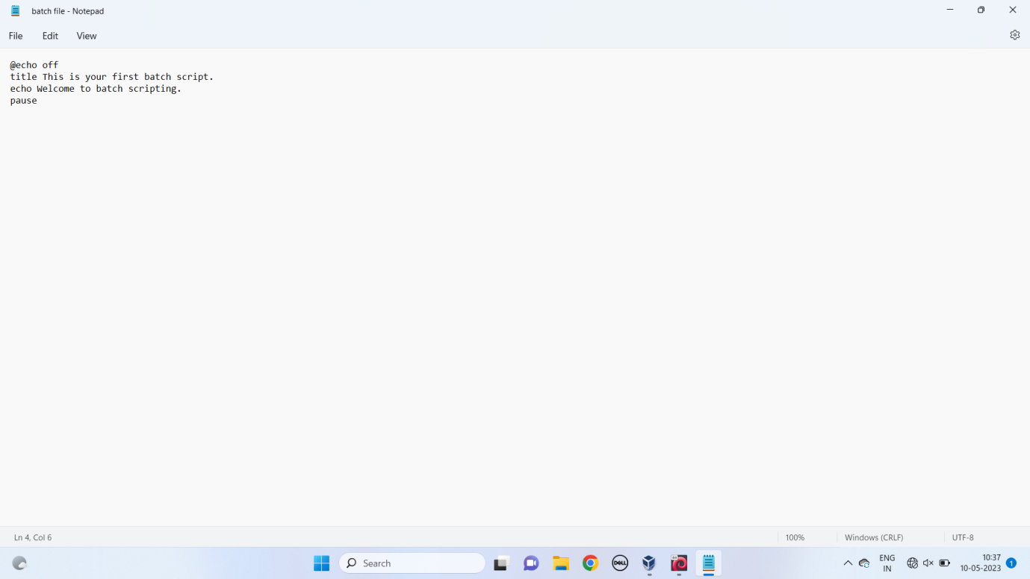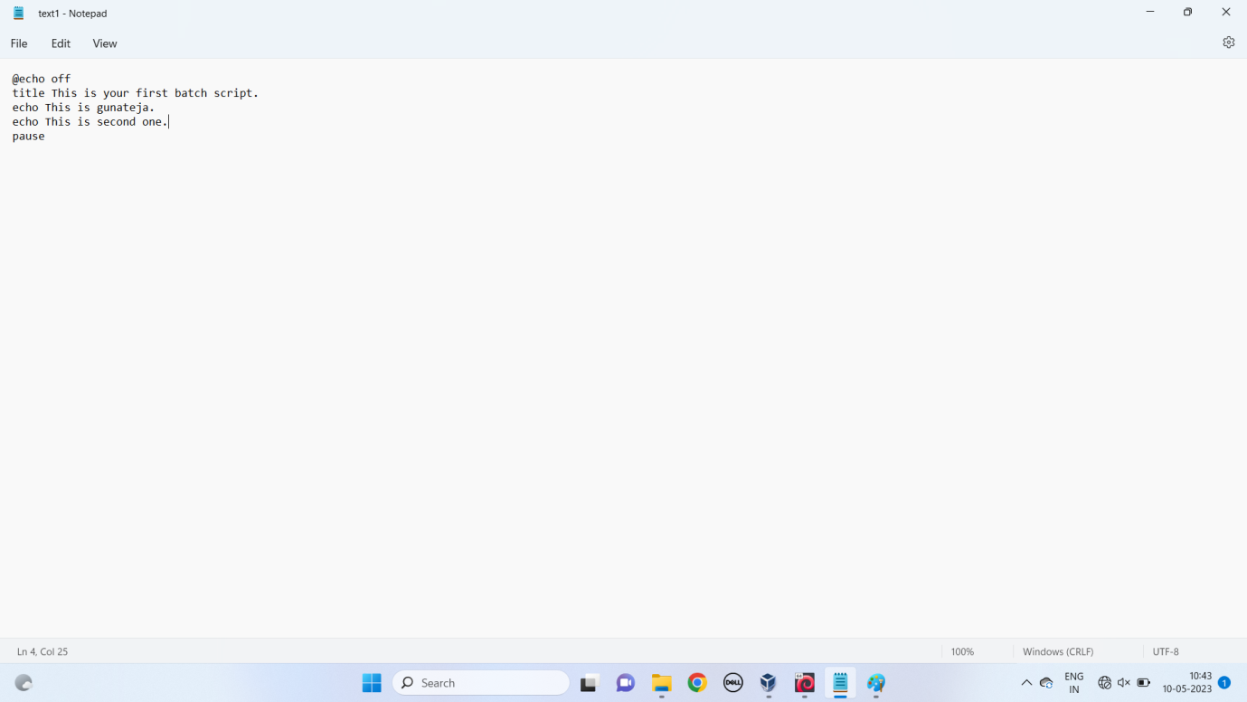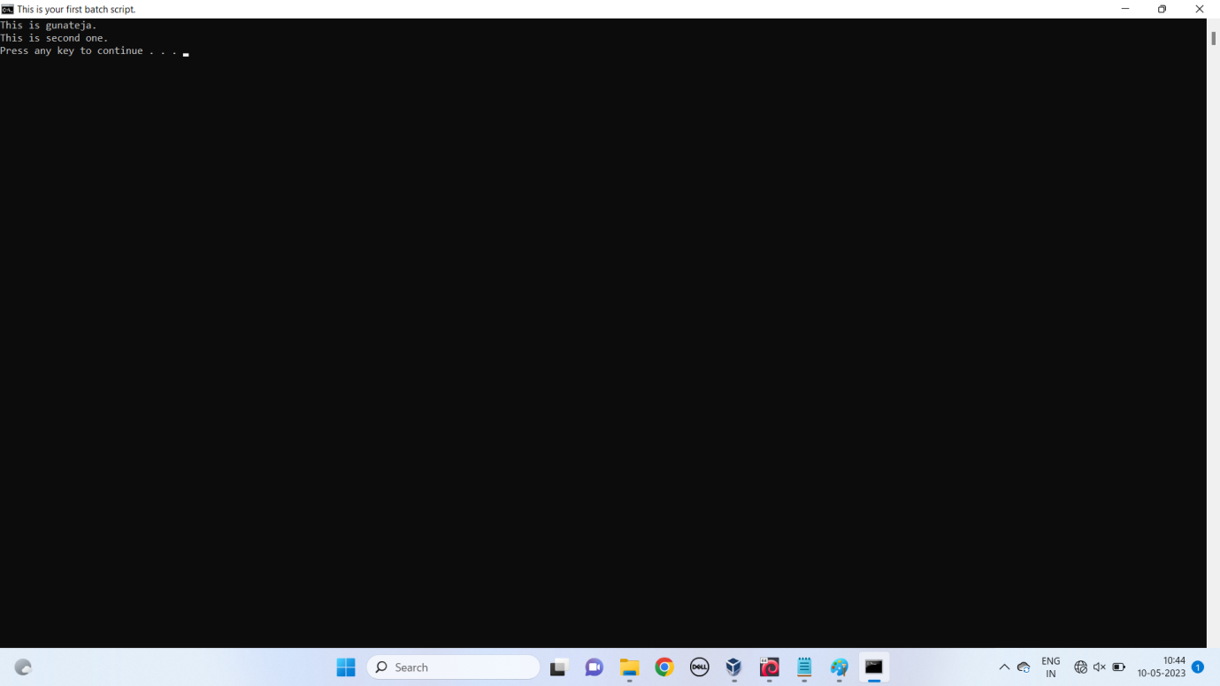

**RESULT:**

Thus the Creation and execution of BATCH FILE was successfully completed.